DT Human Activity Assignment

Raphael J. Malims 663762
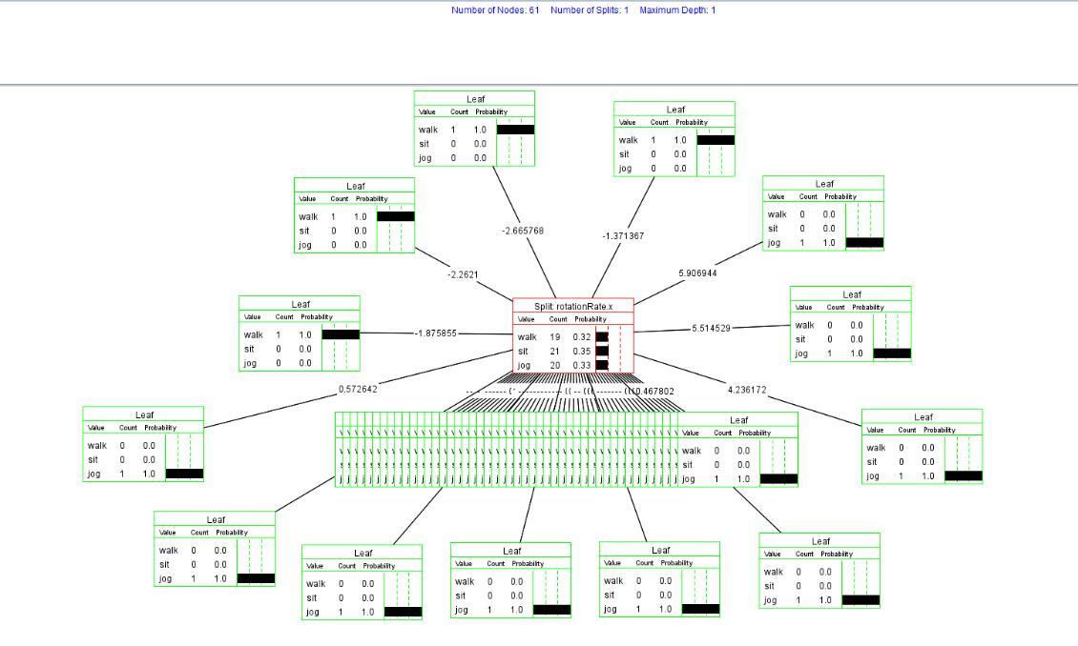

Explanation:

I employed the DTree Java App to analyze device motion, specifically targeting userAcceleration.x, userAcceleration.y, rotationRate.x, and class columns. The decision tree was designed to distinguish between sitting, walking, and jogging activities. The dataset comprised 78 rows, split into 60 for training and 19 for testing.
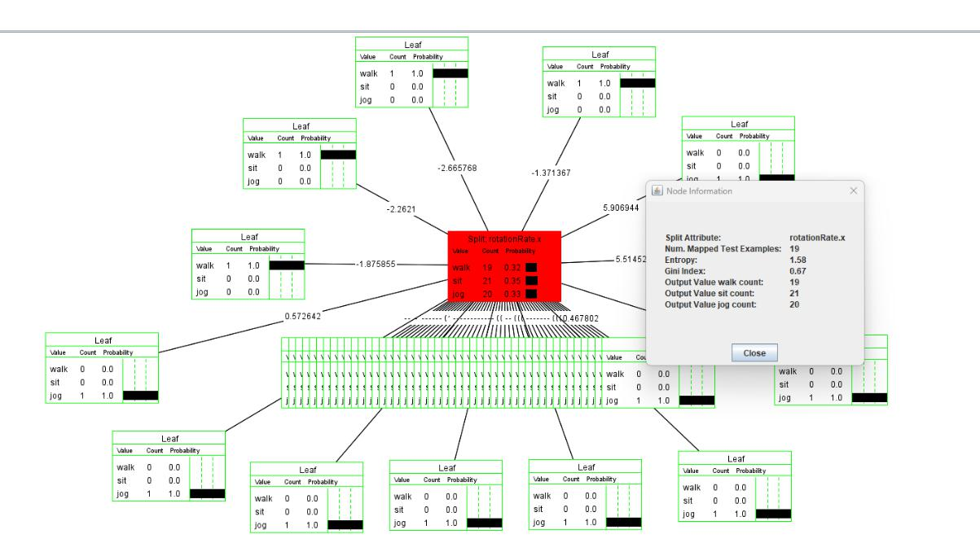
Explanations:

In my examination, I underscored the significance of rotationRate.x within the decision tree. The noteworthy entropy of 1.58 emphasized its efficiency in accurately categorizing the data. This minimal entropy indicated the pivotal role of rotationRate.x in establishing clear groupings for precise classification in my scenario.

Data Exploration:
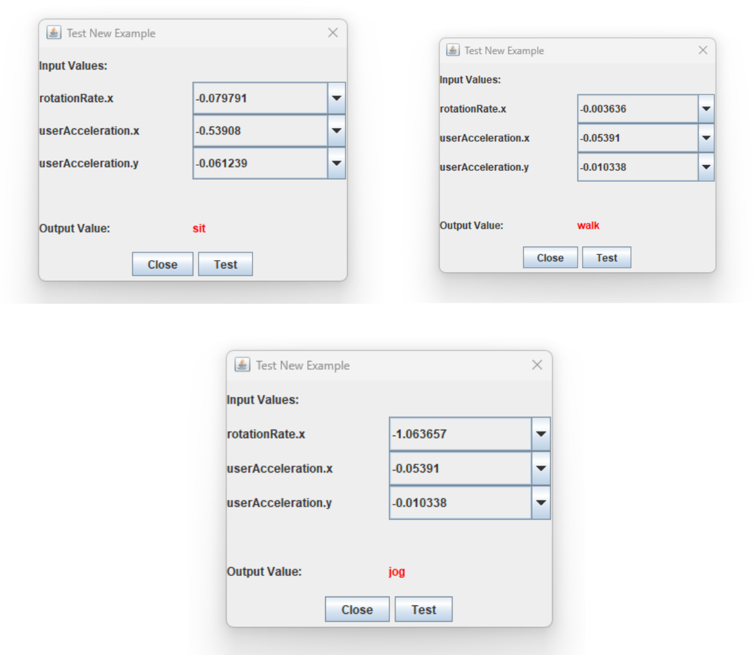

Explanation: The above is a brief glimpse into the exploration of different data points to show that data does vary.
Code:

Using the provided data, I constructed a decision tree, visualized it, conducted testing, and assessed its accuracy, resulting in a 72% precision rate. The code to how I achieved this is below:

import pandas as pd

data = pd.read_csv('/content/data.csv', header='infer')

data

 | rotationRate.x | userAcceleration.x | userAcceleration.y class
0 | -2.548994 | 0.391979 | 0.913534 | walk
1 | -2.665768 | 0.611504 | 0.886597 | walk
2 | -2.854574 | 0.636739 | 0.767762 | walk
3 | -2.516332 | 0.581910 | 0.588902 | walk
4 | -2.262100 | 0.164042 | 0.029239 | walk
.. | ... | ... | ... ...
73 | 2.783017 | -0.953833 | -0.061239 | jog
74 | 4.236172 | -0.579825 | 2.112855 | jog
75 | 5.514529 | -0.846420 | 2.751029 | jog
76 | 5.906944 | -0.541555 | 0.921610 | jog
77 | 4.903476 | 0.001728 | 0.208539 | jog

[78 rows x 4 columns]

data.info()

<class 'pandas.core.frame.DataFrame'>
RangeIndex: 78 entries, 0 to 77
Data columns (total 4 columns):
# | Column | Non-Null Count |  | Dtype
--- | ------ | -------------- |  | -----
0 | rotationRate.x | 78 | non-null | float64
1 | userAcceleration.x | 78 | non-null | float64
2 | userAcceleration.y | 78 | non-null | float64
3 | class | 78 | non-null | object
dtypes: float64(3), object(1)

memory usage: 2.6+ KB

data['class']

- walk
- walk

- walk
- walk
- walk

...
- jog
- jog
- jog
- jog
- jog

Name: class, Length: 78, dtype: object

from sklearn import tree

- = data['class']

y

- walk
- walk
- walk
- walk
- walk
...

- jog
- jog
- jog
- jog
- jog

Name: class, Length: 78, dtype: object

- = data.drop(['class'], axis = 1)

X

 | rotationRate.x | userAcceleration.x | userAcceleration.y
0 | -2.548994 | 0.391979 | 0.913534
1 | -2.665768 | 0.611504 | 0.886597
2 | -2.854574 | 0.636739 | 0.767762
3 | -2.516332 | 0.581910 | 0.588902
4 | -2.262100 | 0.164042 | 0.029239
.. | ... | ... | ...
73 | 2.783017 | -0.953833 | -0.061239
74 | 4.236172 | -0.579825 | 2.112855
75 | 5.514529 | -0.846420 | 2.751029
76 | 5.906944 | -0.541555 | 0.921610
77 | 4.903476 | 0.001728 | 0.208539

[78 rows x 3 columns]

clf = tree.DecisionTreeClassifier(criterion='entropy', max_depth = 3)

clf

DecisionTreeClassifier(criterion='entropy', max_depth=3)

clf = clf.fit(X,y)

clf

DecisionTreeClassifier(criterion='entropy', max_depth=3)

import pydotplus

from IPython.display import Image

dot_data = tree.export_graphviz(clf, feature_names = X.columns, class_names = ['walk', 'sit', 'jog'], filled = True, out_file = None)
graph = pydotplus.graph_from_dot_data(dot_data)

Image(graph.create_png())
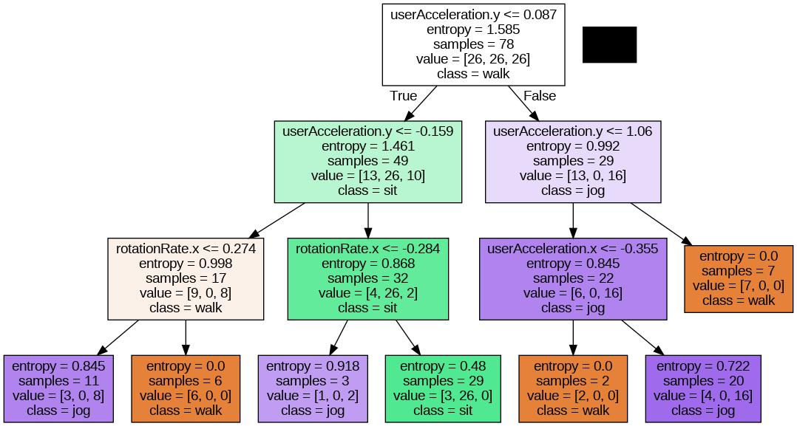

testData=pd.read_csv('/content/testing2.csv',header='infer')

testData

 | rotationRate.x | userAcceleration.x | userAcceleration.y class
0 | 0.362281 | -0.093681 | -0.556827 | walk
1 | 0.035447 | -0.132940 | -0.578839 | walk
2 | -0.277767 | -0.140426 | -0.551390 | walk
3 | -0.658007 | -0.138939 | -0.447676 | walk
4 | -1.088610 | -0.134953 | -0.351983 | walk
.. | ... | ... | ... ...
56 | -0.375877 | 1.438368 | 0.284167 | jog
57 | -5.429132 | 3.572135 | -1.175655 | jog
58 | -10.613199 | 2.616796 | -1.676538 | jog
59 | -0.175480 | 0.746894 | -0.416966 | jog
60 | 2.228408 | -0.085134 | 0.587051 | jog

[61 rows x 4 columns]

testData = pd.DataFrame(testData, columns = data.columns)

testData

 | rotationRate.x | userAcceleration.x | userAcceleration.y class
0 | 0.362281 | -0.093681 | -0.556827 | walk
1 | 0.035447 | -0.132940 | -0.578839 | walk
2 | -0.277767 | -0.140426 | -0.551390 | walk
3 | -0.658007 | -0.138939 | -0.447676 | walk
4 | -1.088610 | -0.134953 | -0.351983 | walk
.. | ... | ... | ... ...
56 | -0.375877 | 1.438368 | 0.284167 | jog
57 | -5.429132 | 3.572135 | -1.175655 | jog
58 | -10.613199 | 2.616796 | -1.676538 | jog
59 | -0.175480 | 0.746894 | -0.416966 | jog

60 2.228408 -0.085134 0.587051 jog

[61 rows x 4 columns]

testY = testData['class']

testX = testData.drop(['class'], axis = 1)

predY = clf.predict(testX)

predY

array(['jog', 'walk', 'walk', 'walk', 'walk', 'walk', 'walk', 'walk', 'walk', 'walk', 'walk', 'sit', 'walk', 'walk', 'sit', 'walk', 'walk', 'walk', 'walk', 'walk', 'walk', 'sit', 'sit', 'sit', 'sit', 'sit', 'sit', 'sit', 'sit', 'sit', 'sit', 'sit', 'sit', 'sit', 'sit', 'sit', 'sit', 'sit', 'sit', 'sit', 'sit', 'walk', 'jog', 'jog', 'walk', 'walk', 'walk', 'walk', 'walk', 'walk', 'walk', 'jog', 'jog', 'jog', 'jog', 'walk', 'walk', 'walk', 'walk', 'walk', 'walk'], dtype=object)

predictions = pd.concat([testData['class'], pd.Series(predY, name =
'Predicted Class')], axis = 1)

predictions

 | class Predicted Class
0 | walk | jog
1 | walk | walk
2 | walk | walk
3 | walk | walk
4 | walk | walk
.. ... |  | ...
56 | jog | walk
57 | jog | walk
58 | jog | walk
59 | jog | walk
60 | jog | walk

[61 rows x 2 columns]

from sklearn.metrics import accuracy_score accuracy_score(testY,predY)
0.7213114754098361

maxDepth = [2,3,4,5,6,7,8,9,10,15,20,25,30,35,40,45,50] maxDepth

[2, 3, 4, 5, 6, 7, 8, 9, 10, 15, 20, 25, 30, 35, 40, 45, 50]

import numpy as np

trainAcc =np.zeros(len(maxDepth))

trainAcc

array([0., 0., 0., 0., 0., 0., 0., 0., 0., 0., 0., 0., 0., 0., 0., 0., 0.])
testAcc = np.zeros(len(maxDepth))

testAcc

array([0., 0., 0., 0., 0., 0., 0., 0., 0., 0., 0., 0., 0., 0., 0., 0., 0.])

index = 0
for depth in maxDepth:

clf = tree.DecisionTreeClassifier(max_depth = depth)
clf = clf.fit(X,y)
Y_predTrain = clf.predict(X)

Y_predTest = clf.predict(testX)

trainAcc[index] = accuracy_score(y, Y_predTrain) testAcc[index] = accuracy_score(testY, Y_predTest) index +=1

trainAcc

array([0.74358974, 0.87179487, 0.93589744, 0.97435897, 0.97435897,
0.98717949, |  | 0.98717949, |  | 1. | , | 1. | , | 1. | ,
1. | , | 1. | , | 1. | , | 1. | , | 1. | ,
1. | , | 1. | ])

testAcc

array([0.63934426, 0.72131148, 0.75409836, 0.7704918 , 0.86885246, 0.86885246, 0.86885246, 0.90163934, 0.7704918 , 0.90163934, 0.80327869, 0.8852459 , 0.8852459 , 0.8852459 , 0.80327869,

0.90163934, 0.86885246])

import matplotlib.pyplot as plt
plt.plot(maxDepth, trainAcc, 'ro-', maxDepth, testAcc, 'bv--')

plt.legend(['Training Accuracy', 'Test Accuracy'])
plt.xlabel('Max Depth')

plt.ylabel('Accuracy')

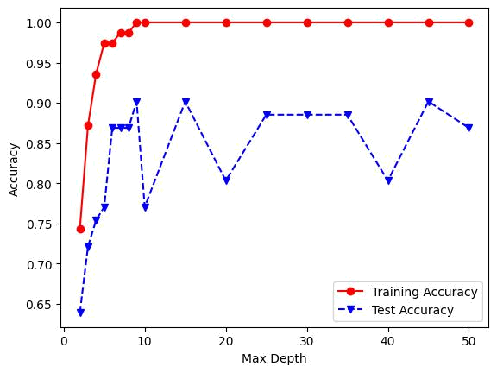
Text(0, 0.5, 'Accuracy')

